**CPE223 – Signals and Systems**



**Lab # 7**

**To Sketch the Line Spectrum of Periodic Signals Using Properties o Fourier Series Coefficients in MATLAB**

|  |  |
| --- | --- |
| **Name** | Muhammad Aizaz Arshad |
| **Registration Number** | 088 |
| **Class** | FA18-BCE-A |
| **Instructor’s Name** | Umair Khan |

**OBJECTIVE:**

Construct the complex exponential and trigonometry Fourier series coefficients and display the line spectrum of periodic signals.

**REQUIRED EQUIPMENT:**

**Software:**

* **MATLAB**

**METHODOLOGY:**

Fourier series are used to convert the continuous time signals into a frequency domain, for conversion first define the signal in the time domain with the variable (t).

Now define the range of number of samples for which we have to find the fourier series of the given continuous time signal.

Next to calculate the coefficients (ak), use the following equation:



where, k is any real number.

Plot the approximated signal for the given samples in the frequency domain and for trigonometric fourier series first define the signal and then calculate the trigonometric coefficient according to the equation given:





After that signal is approximated according to the given number of samples and plot the signal in frequency domain with the given samples.

**CONCLUSION:**

There are two types of Fourier series, Trigonometric Fourier Series and Complex Exponential Fourier Series by which we can transform signal from time domain to frequency domain. Fourier series is only used for periodic signals by calculating their time period and we can express output in coefficients. We have used different properties of series, of linearity, shifting, scaling etc. Learnt about, Parseval’s theorem which is used to calculate power of the signal.

**IN LAB TASKS:**

**Question 1:**

T=2;

to=0;

syms t

x=heaviside(t)-heaviside(t-1);

w=2*pi./T;

subplot(3,2,1)

ezplot(x,[to to+T]);

title('original x(t)')

for k=-2:2

a(k+3)=(1./T).*int(x.*exp(-j*k*w*t),t,to,to+T);

end

for k=-2:2

ex(k+3)=exp(j*k*w*t);

end

x1=sum(a.*ex)

subplot(3,2,2)

ezplot(x1,[to to+T])

title('Approximation with 5 terms')

for k=-5:5

a(k+6)=(1./T).*int(x.*exp(-j*k*w*t),t,to,to+T);

end

for k=-5:5

ex(k+6)=exp(j*k*w*t);

end

x2=sum(a.*ex)

subplot(3,2,3)

ezplot(x2,[to to+T])

title('Approximation with 11 terms')

for k=-10:10

a(k+11)=(1./T).*int(x.*exp(-j*k*w*t),t,to,to+T);

end

for k=-10:10

ex(k+11)=exp(j*k*w*t);

end

x3=sum(a.*ex)

subplot(3,2,4)

ezplot(x3,[to to+T])

title('Approximation with 21 terms')

for k=-30:30

a(k+31)=(1./T).*int(x.*exp(-j*k*w*t),t,to,to+T);

end

for k=-30:30

ex(k+31)=exp(j*k*w*t);

end

x4=sum(a.*ex)

subplot(3,2,5)

ezplot(x4,[to to+T])

title('Approximation with 61 terms')

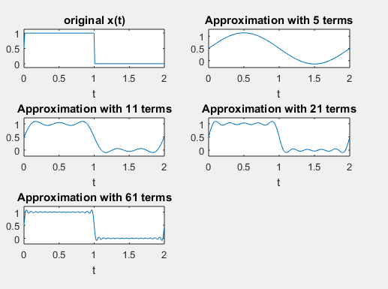

**Question 2:**

to=0;

T=2;

syms t

x=heaviside(t)-heaviside(t-1);

w=2*pi/T;

k=-5:5 ;

a=(1/T)*int(x*exp(-j*k*w*t),t,to,to+T);

subplot(1,2,1)

stem(k,abs(eval(a)))

title('Magnitude spectrum k=-5:5')

k1=-40:40 ;

b=(1/T)*int(x*exp(-j*k1*w*t),t,to,to+T);

subplot(1,2,2)

stem(k1,abs(eval(b)))

title('Magnitude spectrum k=-40:40')

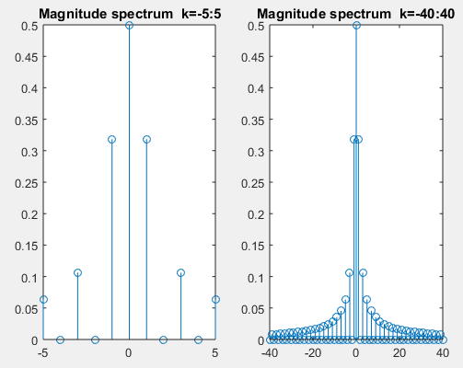

**Question 3:**

T=2;

to=0;

syms t

x=heaviside(t)-heaviside(t-1);

wo=2*pi./T;

k1=-5:5;

ao=(1/T).*int(x,t,to,to+T);

ak=((2/T).*int(x.*cos(k1.*wo.*t),t,to,to+T));

bk=((2/T).*int(x.*sin(k1.*wo.*t),t,to,to+T))

subplot(1,2,1)

stem(ao);

hold on

stem(ak)

hold on

stem(bk)

title('k=-5:5')

legend('ao','ak','bk')

k2=-40:40;

ao=(1/T).*int(x,t,to,to+T);

ak=((2/T).*int(x.*cos(k2.*wo.*t),t,to,to+T))

bk=((2/T).*int(x.*sin(k2.*wo.*t),t,to,to+T))

subplot(1,2,2)

stem(ao);

hold on

stem(ak)

hold on

stem(bk)

title('k=-40:40')

legend('ao','ak','bk')

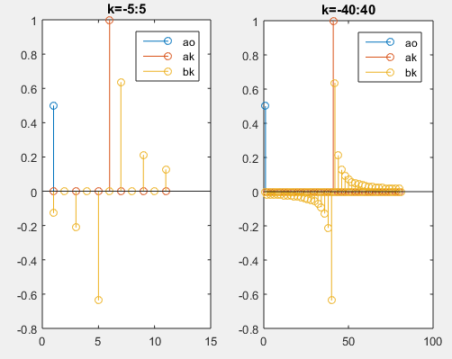

**Question 4:**

T=2.*pi;

to=0;

syms t

x1=cos(t);

x2=sin(2.*t);

z1=3+2j;

z2=2;

a=z1.*x1;

b=z2.*x2;

w=2*pi./T;

k=-5:5;

ak1=((2/T).*int(a.*cos(k.*w.*t),t,to,to+T));

ak2=((2/T).*int(b.*cos(k.*w.*t),t,to,to+T));

ak=ak1+ak2;

subplot(2,1,1)

stem(ak)

title('z1x(t)+z2y(t)')

subplot(2,1,2)

ak3=((2/T).*int(x1.*cos(k.*w.*t),t,to,to+T));

c=z1.*ak3;

ak4=((2/T).*int(x2.*cos(k.*w.*t),t,to,to+T));

d=z2.*ak4;

s=c+d;

stem(s)

title('z1ak+z2bk')

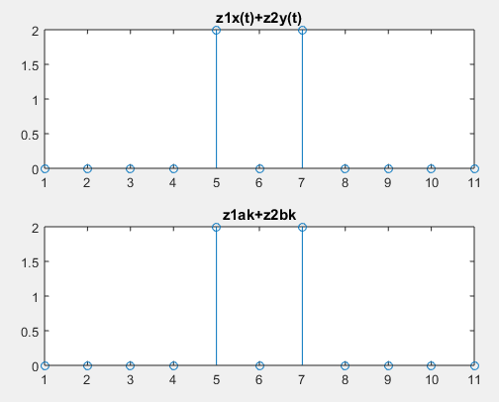

**Question 5:**

to=0;

T=10;

t1=3;

syms t

w=2*pi./T;

x1=t.*exp(-5.*t);

x2=(t+3).*exp(-5.*(t+3));

k=-5:5;

ak=((2/T).*int(x1.*cos(w.*t.*k),t,to,to+T));

ak1=((2/T).*int(x2.*cos(w.*t.*k),t,to,to+T));

subplot(2,1,1)

y=ak.*exp(j.*k.*w.*t1);

stem(abs(y))

title('t.*exp(-5.*t)')

subplot(2,1,2)

y1=ak1.*exp(j.*k.*w.*t1);

stem(abs(y1))

title('(t+3).*exp(-5.*(t+3))')

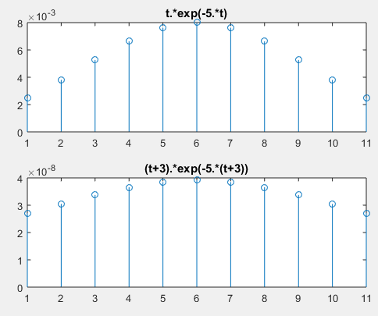

**Question 6:**

T=2.*pi;

to=0;

syms t

x1=t.*cos(t);

x2=(-t)*cos(-t);

wo=2*pi./T;

k1=-5:5;

ak1=((2/T).*int(x1.*cos(k1.*wo.*t),t,to,to+T));

ak2=-ak1;

subplot(2,1,1)

stem(abs(ak1))

title('x(t)')

subplot(2,1,2)

ak3=((2/T).*int(x2.*cos(k1.*wo.*t),t,to,to+T));

stem(abs(ak3))

title('x(-t) verified')

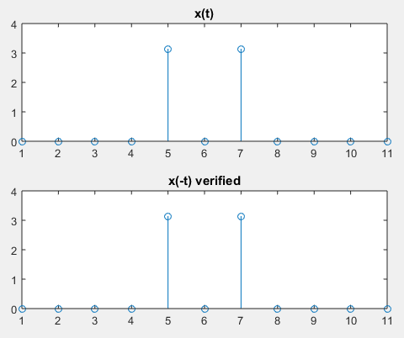

**Question 7:**

syms t

t0=0;

T=2*pi;

w=2*pi/T;

x=cos(t) ;

k=-5:5;

a=(1/T)*int(x*exp(-1i*k*w*t),t,t0,t0+T);

a1=eval(a);

y=sin(t);

b=(1/T)*int(y*exp(-1i*k*w*t),t,t0,t0+T);

b1=eval(b);

left=conv(a1,b1);

subplot(2,2,1);

stem(-10:10,abs(left));

legend('Magnitude');

title(' a_k*b_k Left');

subplot(2,2,2);

stem(-10:10,angle(left));

legend('Angle');

f=x.*y;

k=-10:10;

c=(1/T)*int(f.*exp(-1i*k*w*t),t,t0,t0+T);

c1=eval(c);

subplot(2,2,3);

stem(k,abs(c1));

legend('Magnitude');

title(' x(t)*y(t) Right');

subplot(2,2,4);

stem(k,angle(c1));

legend('Angle');

